Journal of East-Asian Urban History, 1,
December 2019
http://dx.doi.org/10.25020/JoE.2019.2.2.00

TITLE*

Hong, Gil-Dong**
Konkuk University, Rep. of Korea, position(professor)
Kim, An-Na***
Konkuk University, Rep. of Korea, position(student)

ABSTRACT
This study aims to explore characteristics of Korean students' well-being based on PISA (Program for International Students Assessment) of 2015 with OECD participant countries…

Keywords: data, problem-solving, student’ well-being, school science, PISA 2015

Ⅰ. Introduction
How happy are our students at school? It was the starting point of this study. We have worked on keeping our students' cognitive ability status in high level, which used to be the only goal of school science in past years.

1. Students’ life satisfaction
1) Students’ achievement motivation
(1) Prevalence of schoolwork-related anxiety

<Table 1> Correlation coefficient
 | A | B | C | D
Type 1 | .04 | .17* | .00 | .10*
Type 2 | .12* | .36* | .03 | .24*
Type 3 | .09 | .30* | .02 | .19*

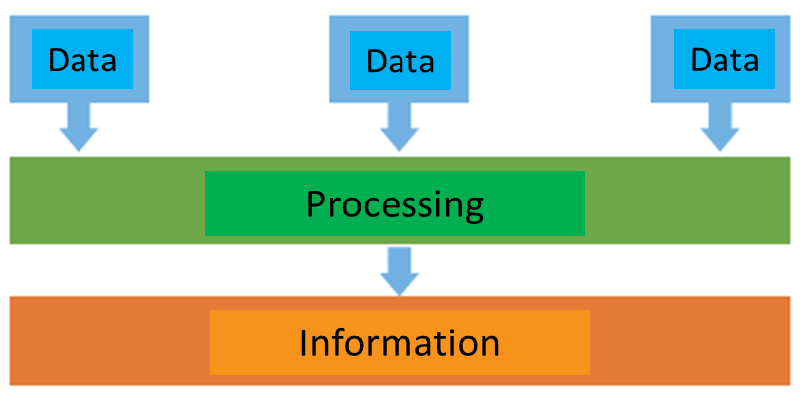
[Figure 1] The process of data

Ⅲ. Conclusion
In this paper, we proposed a training method applicable to software education.

References
Bucher, A. (1998). The influence of models in forming moral identity. International Journal of Educational Research, 27(7), 619-627.
Collins, L. J., Ingoldsby, B. B., & Dellmann, M. M. (1984). Sex role stereotyping in children's literature: A change from the past. Childhood Education, 60, 278-285.
Nunan, D. (1988). The learner-centered curriculum. Cambridge: Cambridge University Press.

* This article was modified or supplemented the author’s master’s thesis or doctoral dissertation.
** First Author: Hong, Gil-Dong(office@easuh.ac.kr)
*** Corresponding Author: Kim, An-Na(kim@easuh.ac.kr)

